Yesterday log file:
2021-08-25 00:00:03.982 EDT [unknown] [unknown] [unknown] 11103 00000 6125c043.2b5f: LOG: connection received: host=slave-server port=41064
2021-08-25 00:00:03.983 EDT [unknown] replicauser [unknown] 11103 00000 6125c043.2b5f: LOG: replication connection authorized: user=replicauser application_name=walreceiver
2021-08-25 00:00:03.984 EDT walreceiver replicauser [unknown] 11103 58P01 6125c043.2b5f: ERROR: requested WAL segment 000000010000028C0000006A has already been removed
2021-08-25 00:00:03.985 EDT walreceiver replicauser [unknown] 11103 00000 6125c043.2b5f: LOG: disconnection: session time: 0:00:00.004 user=replicauser database= host=slave-server port=41064
2021-08-25 00:00:08.986 EDT [unknown] [unknown] [unknown] 11108 00000 6125c048.2b64: LOG: connection received: host=slave-server port=41068
2021-08-25 00:00:08.988 EDT [unknown] replicauser [unknown] 11108 00000 6125c048.2b64: LOG: replication connection authorized: user=replicauser application_name=walreceiver
2021-08-25 00:00:08.989 EDT walreceiver replicauser [unknown] 11108 58P01 6125c048.2b64: ERROR: requested WAL segment 000000010000028C0000006A has already been removed
2021-08-25 00:00:08.990 EDT walreceiver replicauser [unknown] 11108 00000 6125c048.2b64: LOG: disconnection: session time: 0:00:00.004 user=replicauser database= host=slave-server port=4106
scp: /var/lib/pgsql/12/walarchive/000000010000030A000000D8: No space left on device
Archiver error:
2021-08-25 00:00:13.273 EDT 1518 00000 60e71a11.5ee: LOG: archive command failed with exit code 1
2021-08-25 00:00:13.273 EDT 1518 00000 60e71a11.5ee: DETAIL: The failed archive command was: /usr/pgsql-12/bin/syncwal.sh pg_wal/000000010000030A000000D8 000000010000030A000000D8
2021-08-25 00:00:13.273 EDT 1518 01000 60e71a11.5ee: WARNING: archiving write-ahead log file "000000010000030A000000D8" failed too many times, will try again later
2021-08-25 00:00:13.996 EDT [unknown] [unknown] [unknown] 11126 00000 6125c04d.2b76: LOG: connection received: host=slave-server port=41070
2021-08-25 00:00:13.998 EDT [unknown] replicauser [unknown] 11126 00000 6125c04d.2b76: LOG: replication connection authorized: user=replicauser application_name=walreceiver
2021-08-25 00:00:13.999 EDT walreceiver replicauser [unknown] 11126 58P01 6125c04d.2b76: ERROR: requested WAL segment 000000010000028C0000006A has already been removed
2021-08-25 00:00:14.000 EDT walreceiver replicauser [unknown] 11126 00000 6125c04d.2b76: LOG: disconnection: session time: 0:00:00.004 user=replicauser database= host=slave-server port=41070
2021-08-25 00:00:18.996 EDT [unknown] [unknown] [unknown] 11131 00000 6125c052.2b7b: LOG: connection received: host=slave-server port=41072
2021-08-25 00:00:18.997 EDT [unknown] replicauser [unknown] 11131 00000 6125c052.2b7b: LOG: replication connection authorized: user=replicauser application_name=walreceiver
2021-08-25 00:00:18.998 EDT walreceiver replicauser [unknown] 11131 58P01 6125c052.2b7b: ERROR: requested WAL segment 000000010000028C0000006A has already been removed

Until the slave is full
scp: /var/lib/pgsql/12/walarchive/000000010000030A000000D8: No space left on device
Archiver error:
2021-08-25 00:00:11.598 EDT 1518 00000 60e71a11.5ee: LOG: archive command failed with exit code 1
2021-08-25 00:00:11.598 EDT 1518 00000 60e71a11.5ee: DETAIL: The failed archive command was: /usr/pgsql-12/bin/syncwal.sh pg_wal/000000010000030A000000D8 000000010000030A000000D8
…
scp: /var/lib/pgsql/12/walarchive/0000000100000389000000A7: No space left on device
Archiver error:
2021-08-25 23:59:05.846 EDT 1581 00000 61268a5f.62d: LOG: archive command failed with exit code 1
2021-08-25 23:59:05.846 EDT 1581 00000 61268a5f.62d: DETAIL: The failed archive command was: /usr/pgsql-12/bin/syncwal.sh pg_wal/0000000100000389000000A7 0000000100000389000000A7
And clear the slave’s wal files directory:
2021-08-25 03:22:35.427 EDT [unknown] replicauser [unknown] 28875 00000 6125efbb.70cb: LOG: replication connection authorized: user=replicauser application_name=walreceiver
2021-08-25 03:22:35.428 EDT walreceiver replicauser [unknown] 28875 58P01 6125efbb.70cb: ERROR: requested WAL segment 000000010000028C0000006A has already been removed
2021-08-25 03:22:35.429 EDT walreceiver replicauser [unknown] 28875 00000 6125efbb.70cb: LOG: disconnection: session time: 0:00:00.004 user=replicauser database= host=slave-server port=51448
2021-08-25 03:22:40.430 EDT [unknown] [unknown] [unknown] 28880 00000 6125efc0.70d0: LOG: connection received: host=slave-server port=51450
2021-08-25 03:22:40.432 EDT [unknown] replicauser [unknown] 28880 00000 6125efc0.70d0: LOG: replication connection authorized: user=replicauser application_name=walreceiver
2021-08-25 03:22:40.434 EDT walreceiver replicauser [unknown] 28880 58P01 6125efc0.70d0: ERROR: requested WAL segment 000000010000028C0000006A has already been removed
..
2021-08-25 23:59:48.813 EDT walreceiver replicauser [unknown] 55948 00000 612711b4.da8c: LOG: disconnection: session time: 0:00:00.005 user=replicauser database= host=slave-serverport=60114
2021-08-25 23:59:53.815 EDT [unknown] [unknown] [unknown] 56006 00000 612711b9.dac6: LOG: connection received: host=slave-serverport=60116
2021-08-25 23:59:53.816 EDT [unknown] replicauser [unknown] 56006 00000 612711b9.dac6: LOG: replication connection authorized: user=replicauser application_name=walreceiver
2021-08-25 23:59:53.818 EDT walreceiver replicauser [unknown] 56006 58P01 612711b9.dac6: ERROR: requested WAL segment 000000010000028C0000006A has already been removed
2021-08-25 23:59:53.819 EDT walreceiver replicauser [unknown] 56006 00000 612711b9.dac6: LOG: disconnection: session time: 0:00:00.006 user=replicauser database= host=slave-serverport=60116
2021-08-25 23:59:58.822 EDT [unknown] [unknown] [unknown] 56018 00000 612711be.dad2: LOG: connection received: host=slave-serverport=60118
2021-08-25 23:59:58.823 EDT [unknown] replicauser [unknown] 56018 00000 612711be.dad2: LOG: replication connection authorized: user=replicauser application_name=walreceiver
2021-08-25 23:59:58.825 EDT walreceiver replicauser [unknown] 56018 58P01 612711be.dad2: ERROR: requested WAL segment 000000010000028C0000006A has already been removed
2021-08-25 23:59:58.825 EDT walreceiver replicauser [unknown] 56018 00000 612711be.dad2: LOG: disconnection: session time: 0:00:00.005 user=replicauser database= host=slave-serverport=60118

Start push the wal file over slave due to the /var partition is full
2021-08-25 23:59:03.768 EDT [unknown] [unknown] [unknown] 55849 00000 61271187.da29: LOG: connection received: host=slave-serverport=60068
2021-08-25 23:59:03.770 EDT [unknown] replicauser [unknown] 55849 00000 61271187.da29: LOG: replication connection authorized: user=replicauser application_name=walreceiver
2021-08-25 23:59:03.771 EDT walreceiver replicauser [unknown] 55849 58P01 61271187.da29: ERROR: requested WAL segment 000000010000028C0000006A has already been removed
2021-08-25 23:59:03.772 EDT walreceiver replicauser [unknown] 55849 00000 61271187.da29: LOG: disconnection: session time: 0:00:00.005 user=replicauser database= host=slave-serverport=60068
scp: /var/lib/pgsql/12/walarchive/0000000100000389000000A7: No space left on device
Archiver error:
2021-08-25 23:59:04.113 EDT 1581 00000 61268a5f.62d: LOG: archive command failed with exit code 1
2021-08-25 23:59:04.113 EDT 1581 00000 61268a5f.62d: DETAIL: The failed archive command was: /usr/pgsql-12/bin/syncwal.sh pg_wal/0000000100000389000000A7 0000000100000389000000A7
Today log file:

2021-08-26 00:00:03.827 EDT [unknown] [unknown] [unknown] 56038 00000 612711c3.dae6: LOG: connection received: host=slave-serverport=60120
2021-08-26 00:00:03.829 EDT [unknown] replicauser [unknown] 56038 00000 612711c3.dae6: LOG: replication connection authorized: user=replicauser application_name=walreceiver
2021-08-26 00:00:03.830 EDT walreceiver replicauser [unknown] 56038 58P01 612711c3.dae6: ERROR: requested WAL segment 000000010000028C0000006A has already been removed
2021-08-26 00:00:03.830 EDT walreceiver replicauser [unknown] 56038 00000 612711c3.dae6: LOG: disconnection: session time: 0:00:00.005 user=replicauser database= host=slave-serverport=60120
- scp: /var/lib/pgsql/12/walarchive/0000000100000389000000A7: No space left on device
Archiver error:
2021-08-26 00:00:08.357 EDT 1581 00000 61268a5f.62d: LOG: archive command failed with exit code 1
2021-08-26 00:00:08.357 EDT 1581 00000 61268a5f.62d: DETAIL: The failed archive command was: /usr/pgsql-12/bin/syncwal.sh pg_wal/0000000100000389000000A7 0000000100000389000000A7
2021-08-26 00:00:08.836 EDT [unknown] [unknown] [unknown] 56047 00000 612711c8.daef: LOG: connection received: host=slave-serverport=60122
2021-08-26 00:00:08.841 EDT [unknown] replicauser [unknown] 56047 00000 612711c8.daef: LOG: replication connection authorized: user=replicauser application_name=walreceiver
2021-08-26 00:00:08.842 EDT walreceiver replicauser [unknown] 56047 58P01 612711c8.daef: ERROR: requested WAL segment 000000010000028C0000006A has already been removed
2021-08-26 00:00:08.843 EDT walreceiver replicauser [unknown] 56047 00000 612711c8.daef: LOG: disconnection: session time: 0:00:00.009 user=replicauser database= host=slave-serverport=60122
scp: /var/lib/pgsql/12/walarchive/0000000100000389000000AD: No space left on device
Archiver error:
2021-08-26 12:14:23.502 EDT 54389 00000 6127b898.d475: LOG: archive command failed with exit code 1
2021-08-26 12:14:23.502 EDT 54389 00000 6127b898.d475: DETAIL: The failed archive command was: /usr/pgsql-12/bin/syncwal.sh pg_wal/0000000100000389000000AD 0000000100000389000000AD
scp: /var/lib/pgsql/12/walarchive/0000000100000389000000AD: No space left on device
Archiver error:
2021-08-26 12:14:25.212 EDT 54389 00000 6127b898.d475: LOG: archive command failed with exit code 1
2021-08-26 12:14:25.212 EDT 54389 00000 6127b898.d475: DETAIL: The failed archive command was: /usr/pgsql-12/bin/syncwal.sh pg_wal/0000000100000389000000AD 0000000100000389000000AD
2021-08-26 12:14:25.212 EDT 54389 01000 6127b898.d475: WARNING: archiving write-ahead log file "0000000100000389000000AD" failed too many times, will try again later

I stopped slave’s

scp: /var/lib/pgsql/12/walarchive/0000000100000389000000AD: No space left on device
Archiver error:
2021-08-26 12:39:02.440 EDT 54389 00000 6127b898.d475: LOG: archive command failed with exit code 1
2021-08-26 12:39:02.440 EDT 54389 00000 6127b898.d475: DETAIL: The failed archive command was: /usr/pgsql-12/bin/syncwal.sh pg_wal/0000000100000389000000AD 0000000100000389000000AD
2021-08-26 12:39:02.440 EDT 54389 01000 6127b898.d475: WARNING: archiving write-ahead log file "0000000100000389000000AD" failed too many times, will try again later

Before patching
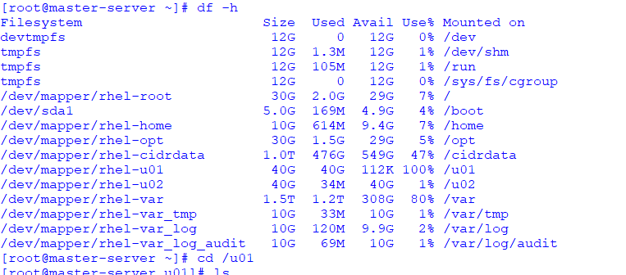
After patching
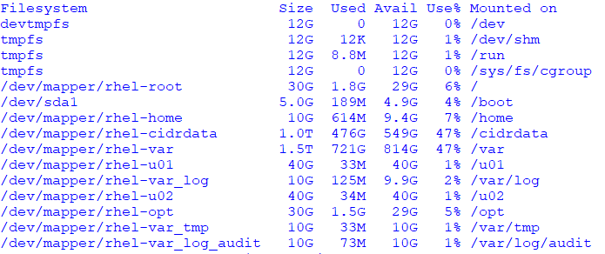

SLAVE’s log
On 8/24
cp: cannot stat ‘/var/lib/psql/12/walarchive/00000002.history’: No such file or directory
cp: cannot stat ‘/var/lib/psql/12/walarchive/000000010000028C0000006A’: No such file or directory
2021-08-24 00:01:47.970 EDT 38812 00000 61246f2b.979c: LOG: started streaming WAL from primary at 28C/6A000000 on timeline 1
2021-08-24 00:01:47.970 EDT 38812 XX000 61246f2b.979c: FATAL: could not receive data from WAL stream: ERROR: requested WAL segment 000000010000028C0000006A has already been removed
cp: cannot stat ‘/var/lib/psql/12/walarchive/00000002.history’: No such file or directory
cp: cannot stat ‘/var/lib/psql/12/walarchive/000000010000028C0000006A’: No such file or directory
2021-08-24 00:01:52.972 EDT 38832 00000 61246f30.97b0: LOG: started streaming WAL from primary at 28C/6A000000 on timeline 1
2021-08-24 00:01:52.972 EDT 38832 XX000 61246f30.97b0: FATAL: could not receive data from WAL stream: ERROR: requested WAL segment 000000010000028C0000006A has already been removed
cp: cannot stat ‘/var/lib/psql/12/walarchive/00000002.history’: No such file or directory
cp: cannot stat ‘/var/lib/psql/12/walarchive/000000010000028C0000006A’: No such file or directory
2021-08-24 00:01:57.978 EDT 38839 00000 61246f35.97b7: LOG: started streaming WAL from primary at 28C/6A000000 on timeline
8/25/2021
2021-08-25 00:00:00.232 EDT 1501 53100 60afdb07.5dd: LOG: could not open file "current_logfiles.tmp": No space left on device
cp: cannot stat ‘/var/lib/psql/12/walarchive/000000010000028C0000006A’: No such file or directory
2021-08-25 00:00:02.228 EDT 44934 00000 6125c042.af86: LOG: started streaming WAL from primary at 28C/6A000000 on timeline 1
2021-08-25 00:00:02.228 EDT 44934 XX000 6125c042.af86: FATAL: could not receive data from WAL stream: ERROR: requested WAL segment 000000010000028C0000006A has already been removed
cp: cannot stat ‘/var/lib/psql/12/walarchive/00000002.history’: No such file or directory
cp: cannot stat ‘/var/lib/psql/12/walarchive/000000010000028C0000006A’: No such file or directory
2021-08-25 00:00:07.228 EDT 44960 00000 6125c047.afa0: LOG: started streaming WAL from primary at 28C/6A000000 on timeline 1
2021-08-25 00:00:07.228 EDT 44960 XX000 6125c047.afa0: FATAL: could not receive data from WAL stream: ERROR: requested WAL segment 000000010000028C0000006A has already been removed
cp: cannot stat ‘/var/lib/psql/12/walarchive/00000002.history’: No such file or directory
cp: cannot stat ‘/var/lib/psql/12/walarchive/000000010000028C0000006A’: No such file or directory
2021-08-25 00:00:12.233 EDT 44967 00000 6125c04c.afa7: LOG: started streaming WAL from primary at 28C/6A000000 on timeline 1
..
2021-08-25 21:55:54.321 EDT 20008 00000 6126f4aa.4e28: LOG: started streaming WAL from primary at 28C/6A000000 on timeline 1
2021-08-25 21:55:54.321 EDT 20008 XX000 6126f4aa.4e28: FATAL: could not receive data from WAL stream: ERROR: requested WAL segment 000000010000028C0000006A has already been removed
cp: cannot stat ‘/var/lib/psql/12/walarchive/00000002.history’: No such file or directory
cp: cannot stat ‘/var/lib/psql/12/walarchive/000000010000028C0000006A’: No such file or directory
2021-08-25 21:55:59.293 EDT 20031 00000 6126f4af.4e3f: LOG: started streaming WAL from primary at 28C/6A000000 on timeline 1
Today log:
2021-08-26 00:00:00.065 EDT 48486 53100 61269d9a.bd66: LOG: could not open file "current_logfiles.tmp": No space left on device
cp: cannot stat ‘/var/lib/psql/12/walarchive/000000010000028C0000006A’: No such file or directory
2021-08-26 00:00:02.064 EDT 39105 00000 612711c2.98c1: LOG: started streaming WAL from primary at 28C/6A000000 on timeline 1
2021-08-26 00:00:02.064 EDT 39105 XX000 612711c2.98c1: FATAL: could not receive data from WAL stream: ERROR: requested WAL segment 000000010000028C0000006A has already been removed
..
2021-08-26 00:00:57.122 EDT 39269 XX000 612711f9.9965: FATAL: could not receive data from WAL stream: ERROR: requested WAL segment 000000010000028C0000006A has already been removed
cp: cannot stat ‘/var/lib/psql/12/walarchive/00000002.history’: No such file or directory
cp: cannot stat ‘/var/lib/psql/12/walarchive/000000010000028C0000006A’: No such file or directory
2021-08-26 00:01:02.132 EDT 39291 00000 612711fe.997b: LOG: started streaming WAL from primary at 28C/6A000000 on timeline 1
2021-08-26 00:01:02.132 EDT 39291 XX000 612711fe.997b: FATAL: could not receive data from WAL stream: ERROR: requested WAL segment 000000010000028C0000006A has already been removed
cp: cannot stat ‘/var/lib/psql/12/walarchive/00000002.history’: No such file or directory
cp: cannot stat ‘/var/lib/psql/12/walarchive/000000010000028C0000006A’: No such file or directory
2021-08-26 00:01:07.135 EDT 39299 00000 61271203.9983: LOG: started streaming WAL from primary at 28C/6A000000 on timeline 1
2021-08-26 00:01:07.135 EDT 39299 XX000 61271203.9983: FATAL: could not receive data from WAL stream: ERROR: requested WAL segment 000000010000028C0000006A has already been removed
cp: cannot stat ‘/var/lib/psql/12/walarchive/00000002.history’: No such file or directory
cp: cannot stat ‘/var/lib/psql/12/walarchive/000000010000028C0000006A’: No such file or directory
2021-08-26 00:01:12.139 EDT 39306 00000 61271208.998a: LOG: started streaming WAL from primary at 28C/6A000000 on timeline 1
2021-08-26 00:01:12.140 EDT 39306 XX000 61271208.998a: FATAL: could not receive data from WAL stream: ERROR: requested WAL segment 000000010000028C0000006A has already been removed
cp: cannot stat ‘/var/lib/psql/12/walarchive/00000002.history’: No such file or directory
cp: cannot stat ‘/var/lib/psql/12/walarchive/000000010000028C0000006A’: No such file or directory
2021-08-26 00:01:17.151 EDT 39330 00000 6127120d.99a2: LOG: started streaming WAL from primary at 28C/6A000000 on timeline 1
2021-08-26 00:01:17.152 EDT 39330 XX000 6127120d.99a2: FATAL: could not receive data from WAL stream: ERROR: requested WAL segment 000000010000028C0000006A has2021-08-26 09:32:32.233 EDT 48483 00000 61269d9a.bd63: LOG: database system is shut down

After patching and reboot
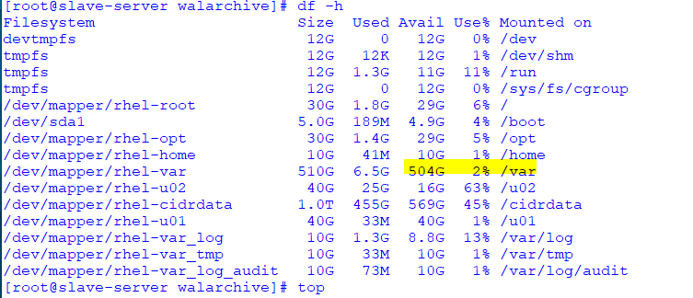
This morning full again

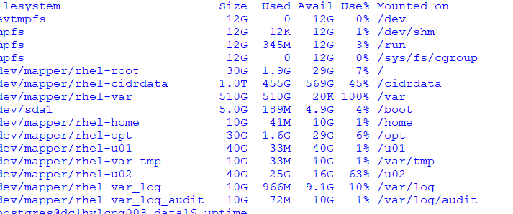

[postgres@slave-server data]$ vi postgresql.auto.conf
# Do not edit this file manually!
# It will be overwritten by the ALTER SYSTEM command.
listen_addresses = '*'
primary_conninfo = 'user=replicauser passfile=''/home/postgres/.pgpass'' host=master_server port=5432 sslmode=prefer sslcompression=0 gssencmode=prefer krbsrvname=postgres target_session_attrs=any'
recovery_target_timeline=latest
promote_trigger_file='/tmp/failover_5432.trigger'
~

# These settings are ignored on a standby server.
synchronous_standby_names = '*'
archive_mode = on # enables archiving; off, on, or always
# (change requires restart)
# archive_command = '/usr/pgsql-12/bin/syncwal.sh %p %f' # command to use to archive a logfile segment

